Summary
Testing Approach
For each of the three parts of project one, my testing approach was closely aligned with the software requirements. I would use the requirements in order to define the testing criteria- ensuring that the full functionality of the software was tested and in line with the projects specific goals. An example would be one of the tests that I configured specifically to meet one of module four’s goals (one of the three segments that make up project one):
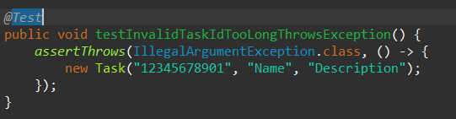
This test exclusively checks whether the TaskID meets the length requirements listed by the project criteria. It exists entirely due to me wanting to closely align my tests with the project specifications, and functions as an example of my intent throughout this assignment.

Experience with JUnit Tests
The overall quality of my JUnit tests was strong. Throughout my project, the coverage percentage dropped to around 80% at the lowest. Granted, this certainly could’ve been higher, but it still maintains that about 80 (plus or minus 10%) of my code was covered by my test cases. Considering that my test cases handled all of the relevant areas listed in the project requirements, it shows that they were thorough and reliable.
In order to ensure that my tests were technically sound, I made sure to validate functionality and address edge cases. An example would be when in the TaskServiceTest file, where I ensured that there couldn’t be duplicate ID’s:
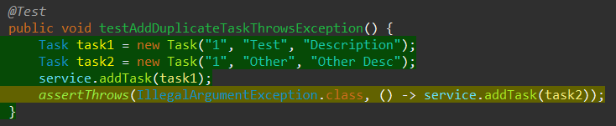
Or, also within this file, I made sure to provide a check that restricted users from updating a non-existent ID:
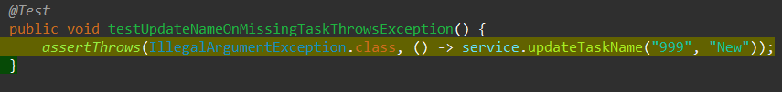
Additionally, I ensured that each of my tests only asserted a single thing. This increases the modularity and enables clearer testing and control of the overall program.
All-in-all, these tests (and the similar ones found throughout this project) help to ensure that a wide variety of situations (edge cases) are accounted for, reducing any bugs or issues from a user-perspective, and increasing the overall technical soundness of my code.
My code was kept efficient by ensuring that my tests were short, descriptive, important and readable. By reducing redundancy and ensuring that each one of my tests’ intent was clear, my code was kept clean and usable. Additionally, I ensured that my setup methods were reusable and that ID’s were used as keys in a HashMap, making the code performant, user-friendly, and organized.
Example of a reusable setup method:
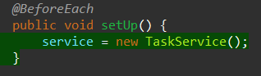

Reflection
Testing Techniques
For each portion of the project, my primary testing method was unit testing utilizing JUnit. Unit testing focuses on testing the individual components that make up the application on their own. It allows one to determine if each segment of the code functions in isolation, allowing one to quickly and decidedly diagnose and resolve any issues that may appear. An example would be any of the screenshots found in this paper.
Testing techniques that I didn’t utilize in this project include integration testing, which tests how the different modules or services work together, system testing, which verifies the system as a whole against the requirements, acceptance testing, which involves that the program meets requirements from the perspective of a user, regression testing, which tests whether changes would break previously functional pieces, and performance testing, which runs the program in a stressful environment and ensures it retains functionality and performance.
Each testing method has different strengths and applications. My primary testing method (Unit Testing) is great for early development and ensuring that isolated logic is correct and functional. It’s fairly quick and easy to automate.
Integration testing (which I did not elect to use), is more applicable when you have multiple modules that all interact with one another, and functions to ensure cohesiveness and functionality of the overall system.
Regression testing (also unused), is more valuable in long-term projects that go through many different iterations and changes, and works to ensure that each additional change doesn’t compromise the previously functional system.

Mindset
While working on this project, I took an extremely cautious approach. I tried to, at times, view the work from a user-perspective, and think about all the interesting and unintended ways in which they may use (and break) my code. Understanding that, I worked to prioritize code that mitigated all of those potential happenings. This is done with verification, of course, but also by writing JUnit tests exclusively to counter this behavior. An example would be when I tried to counter the accident of someone adding an appointment that already exists (in AppointmentServiceTest.java):
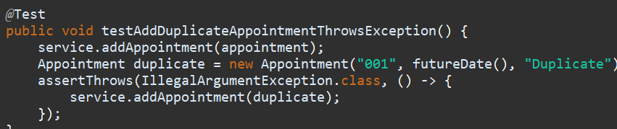
This also comes into countering bias. From trying to view my code from someone less technically-inclined (or someone far more), I was able to see far more ways in which my code could be misused and/or broken. If I had only tried to write my code according to how I would use it, I would certainly miss several important edge cases.

Cutting corners when testing code is extremely problematic for a plethora of reasons. You could miss bugs, edge cases, etc. and just generally sacrifice your codes overall quality. I plan to avoid technical debt by writing tests as I develop, regularly review my code, and keep being as thorough and thoughtful as I can. By prioritizing a thoughtful and cautious approach, I should be able to mitigate the risk of bringing myself (and others) into technical debt.

